**Project Design Phase-1**

Solution architecture

|  |  |
| --- | --- |
| Team ID | PNT2022TMID43975 |
| Project Name | Iot based smart crop protection for agriculture |

**Solution architecture:**

The IoT based smart crop protection system help the farmers to protect the crops from animals and birds. Thus preventing lose for formers and country. The system uses sensors, that captures the image of animals & birds and store it in the ibm cloud. The alarm is switched ON if the system senses any animals or birds. This is done by python program module. This system also helps in monitoring the crops parameters such as moisture, humidity and temperature.All the data are stored in the IBM cloud which can be later analyzed. The motor and sprinklers in the field can controlled using the mobile application. The current status of the crops can be viewed remotely.

**Solution Architecture design:**

 

**Camera Module**

**Mobile**

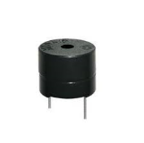



**Ultrasonic Sensor**

Ultrasonic sensor

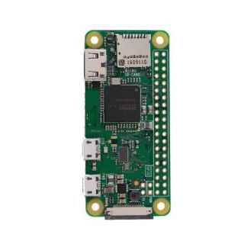

**Temperature**

**Sensor**

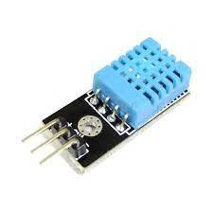



**Solenoid Value**

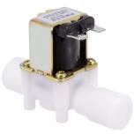

**Buzzer**